**Image Processing Using Pillow Library:**

**(1) from PIL import Image**

**img = Image.open("C:/Users/abc/Desktop/image/test_image.jpg")**

**print(type(img))**

**→ <class 'PIL.JpegImagePlugin.JpegImageFile'>**

**(2) print(img.format)**

**→ JPEG**

**(3) print(img.mode)**

**→ RGB**

**(4) print(img.size)**

**→ (546, 340)**

**(5) from PIL import Image**

**img = Image.open("C:/Users/abc/Desktop/image/test_image.jpg")**

**print(type(img))**

**print(img.size)**

**small_img = img.resize((200,300))**

**small_img.save("C:/Users/abc/Desktop/image/test_image_small.jpg”)**

**→ Original img :**

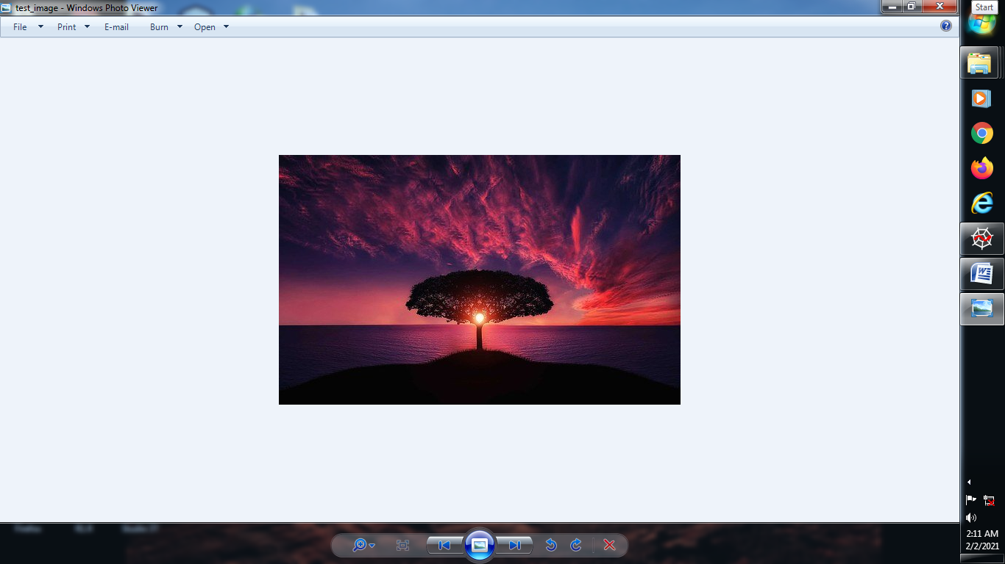

**→ Small img**

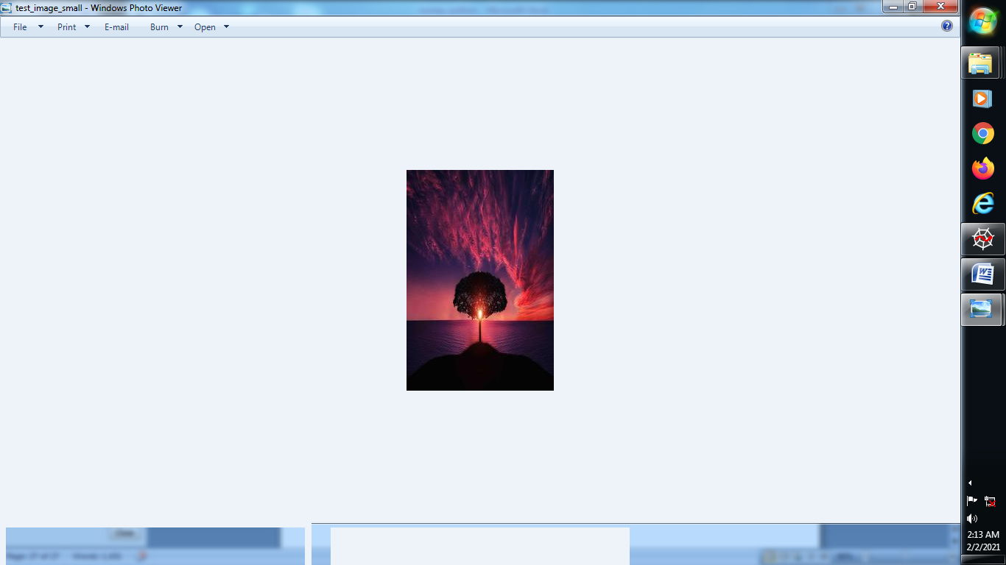

**(6) from PIL import Image**

**img = Image.open("C:/Users/abc/Desktop/image/test_image.jpg")**

**print(img.size)**

**small_img = img.resize((200,300))**

**small_img.save("C:/Users/abc/Desktop/image/test_image_small.jpg")**

**img.thumbnail((200,300))**

**img.save("C:/Users/abc/Desktop/image/test_image_tmbnail.jpg")**

**→ Original Image : size(546,340)**



**→ Small Image: size(200,300)**



**→ Thumbnail Image: size(200,125)**

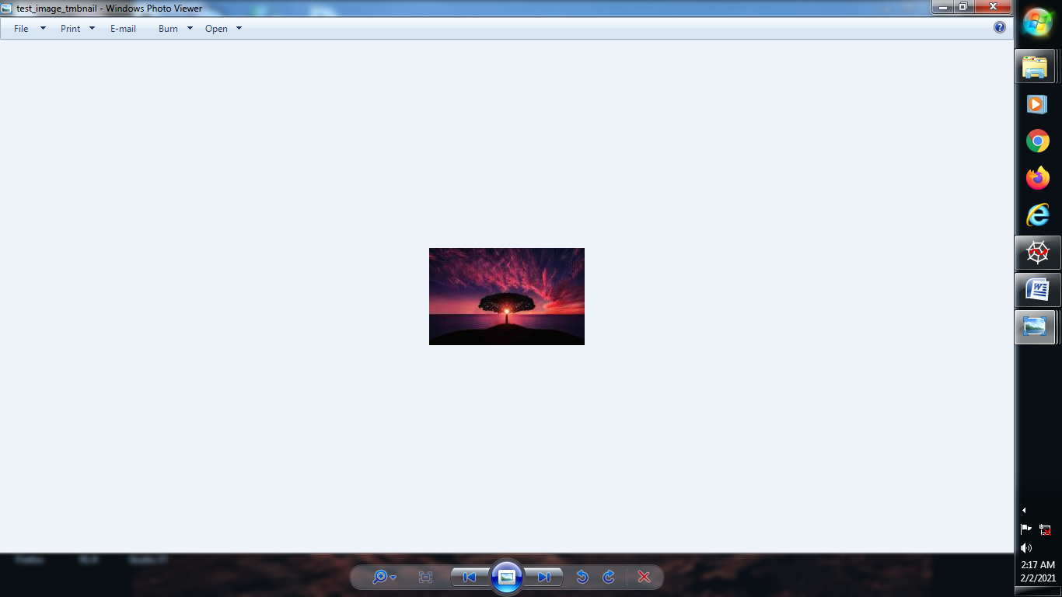

**(7) img.thumbnail((1200,1300))**

**img.save("C:/Users/abc/Desktop/image/test_image_tmbnail.jpg")**

**print(img.size)**

**→ Original image = Thumbnail image**



**(8) crop the image :**

**from PIL import Image**

**img = Image.open("C:/Users/abc/Desktop/image/test_image.jpg")**

**cropped_img = img.crop((0,0,300,300))**

**cropped_img.save("C:/Users/abc/Desktop/image/cropped_img.jpg")**

**→ Original Image :**



**→ Cropped Image :**

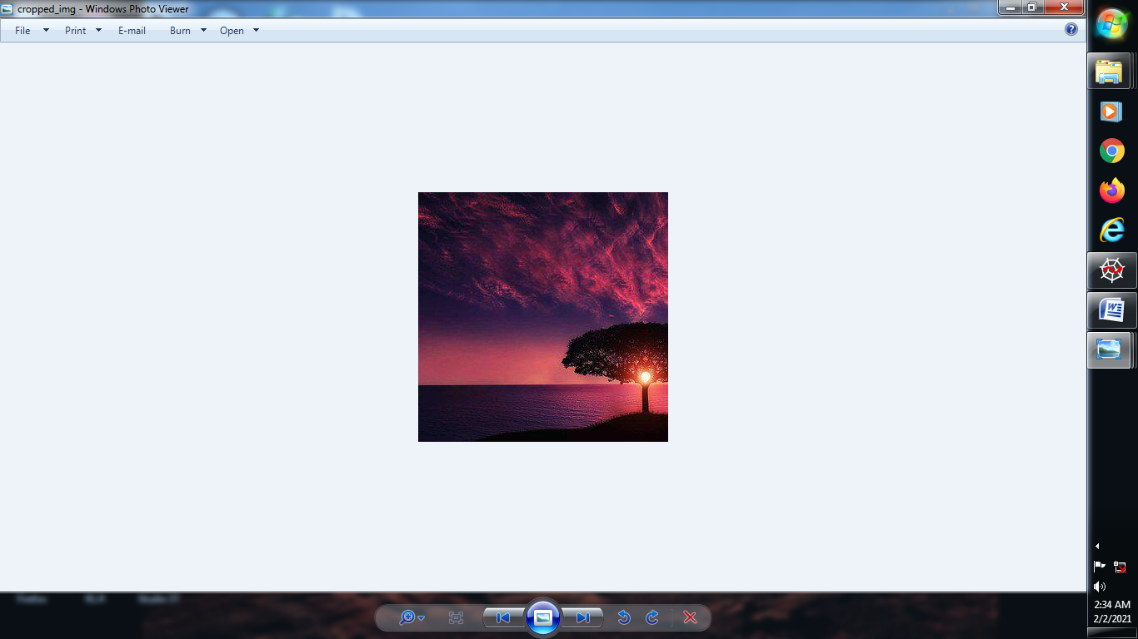

**(9) How to copy and paste one image into another image:**

**from PIL import Image**

**img1 = Image.open("C:/Users/abc/Desktop/image/test_image.jpg")**

**print(img1.size)**

**img2 = Image.open("C:/Users/abc/Desktop/image/lighthouse.jpg")**

**print(img2.size)**

**img2.thumbnail((150,200))**

**img1_copy = img1.copy()**

**img1_copy.paste(img2,(50,50))**

**img1_copy.save("C:/Users/abc/Desktop/image/pasted_image.jpg")**

**→ second image is pasted into first image:**

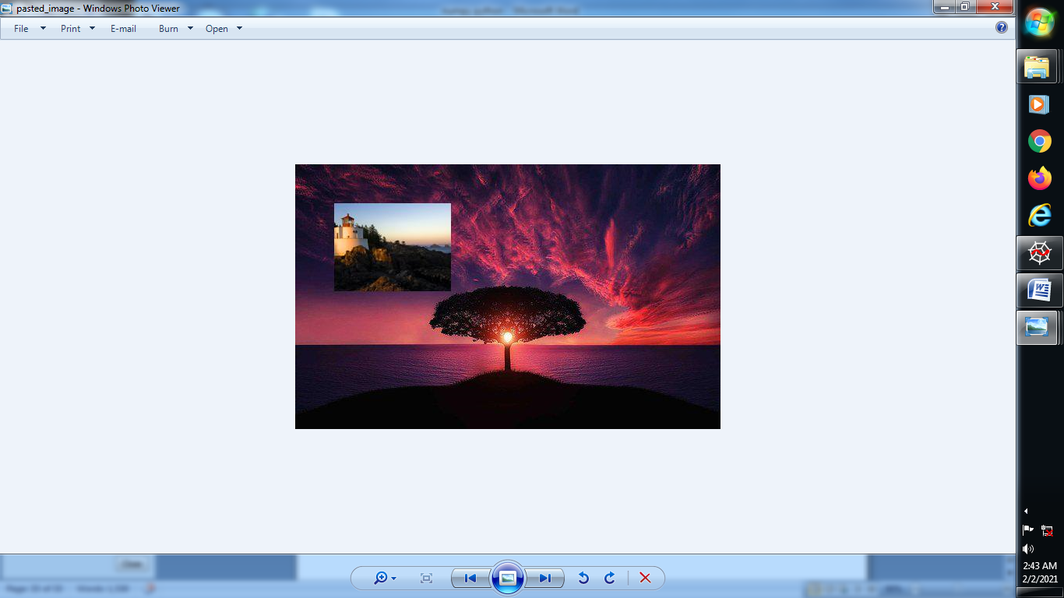

**(10) How to Rotate the image in pillow :**

**from PIL import Image**

**img = Image.open("C:/Users/abc/Desktop/image/test_image.jpg")**

**img90 = img.rotate(90)**

**img90.save("C:/Users/abc/Desktop/image/rotated90.jpg")**

**→ Rotate the image :**

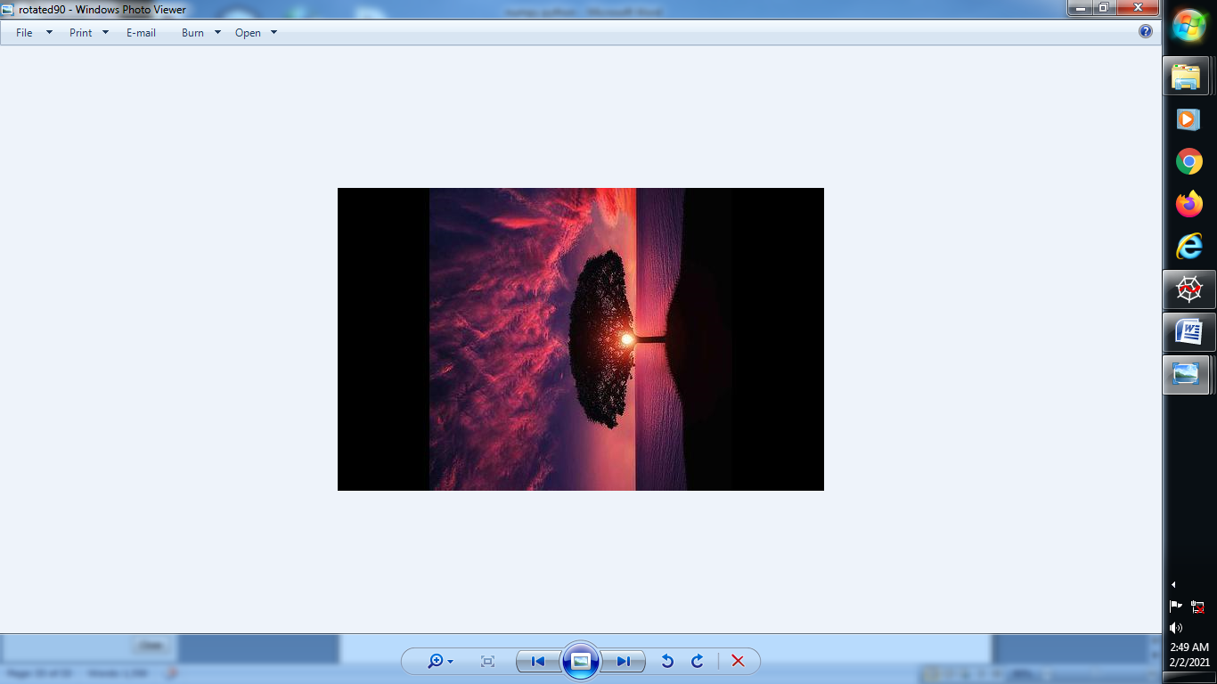

**→ Now Suppose We Rotate 45 degree this upper image:**

**from PIL import Image**

**img = Image.open("C:/Users/abc/Desktop/image/test_image.jpg")**

**img45= img.rotate(45)**

**img45.save("C:/Users/abc/Desktop/image/rotated45.jpg")**

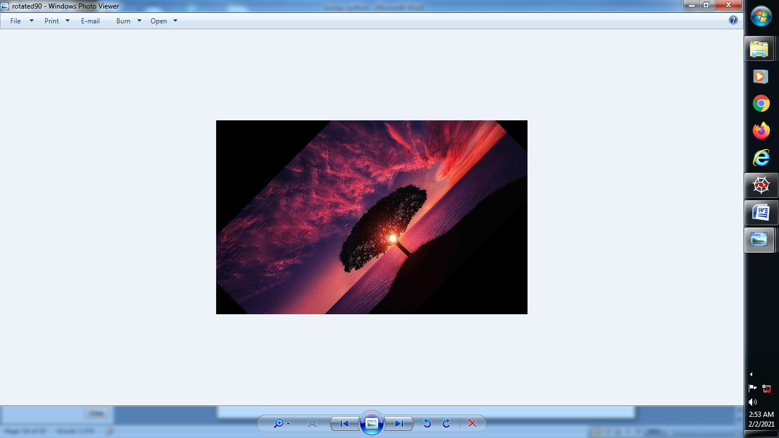

**→ Using Expand function try to rorate this image 45 degree:**

**from PIL import Image**

**img = Image.open("C:/Users/abc/Desktop/image/test_image.jpg")**

**img45= img.rotate(45.expand=TRUE)**

**img45.save("C:/Users/abc/Desktop/image/rotated45.jpg")**

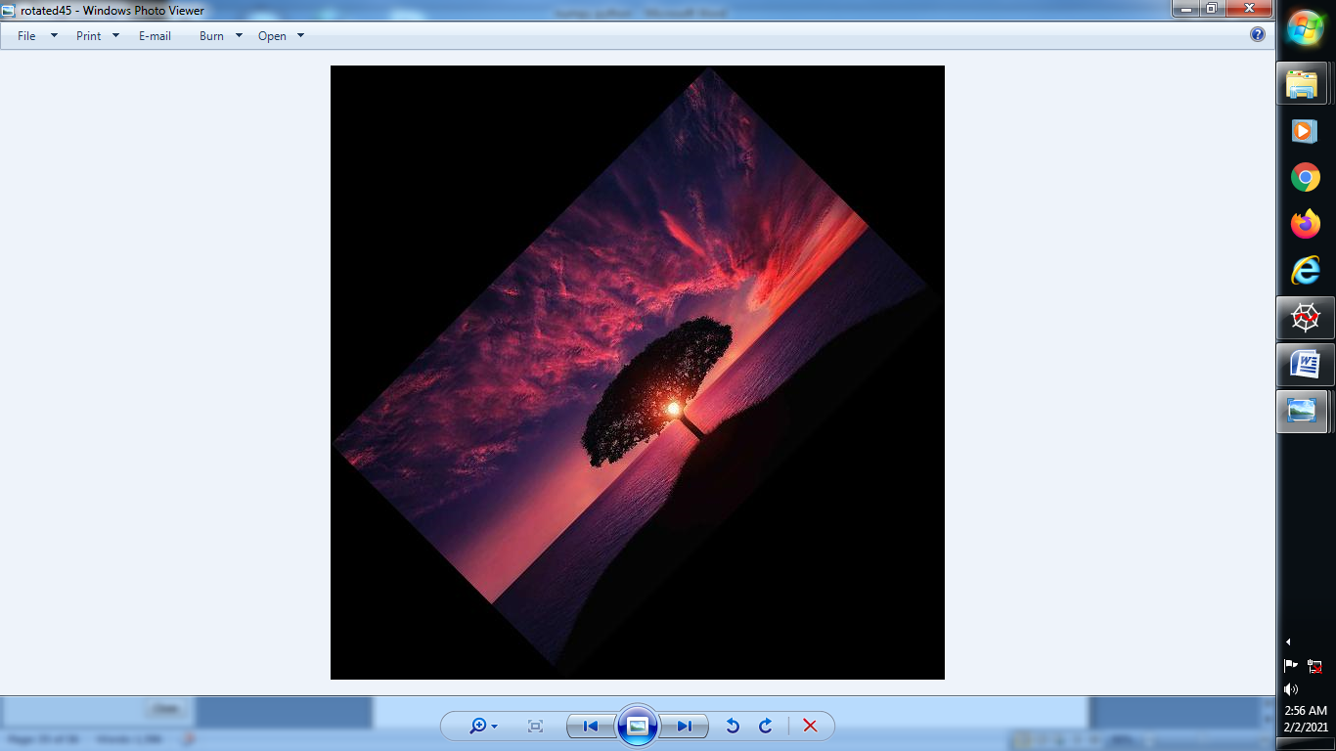

**(11) How to flip the image LEFT TO RIGHT OR TOP TO BOTTOM:**

**LEFT TO RIGHT:**

**from PIL import Image**

**img = Image.open("C:/Users/abc/Desktop/image/test_image.jpg")**

**img_flipLR = img.transpose(Image.FLIP_LEFT_RIGHT)**

**img_flipLR.save("C:/Users/abc/Desktop/image/filppedLR.jpg")**

**→ Original Image:**



**→ Flipped Image(LR)**

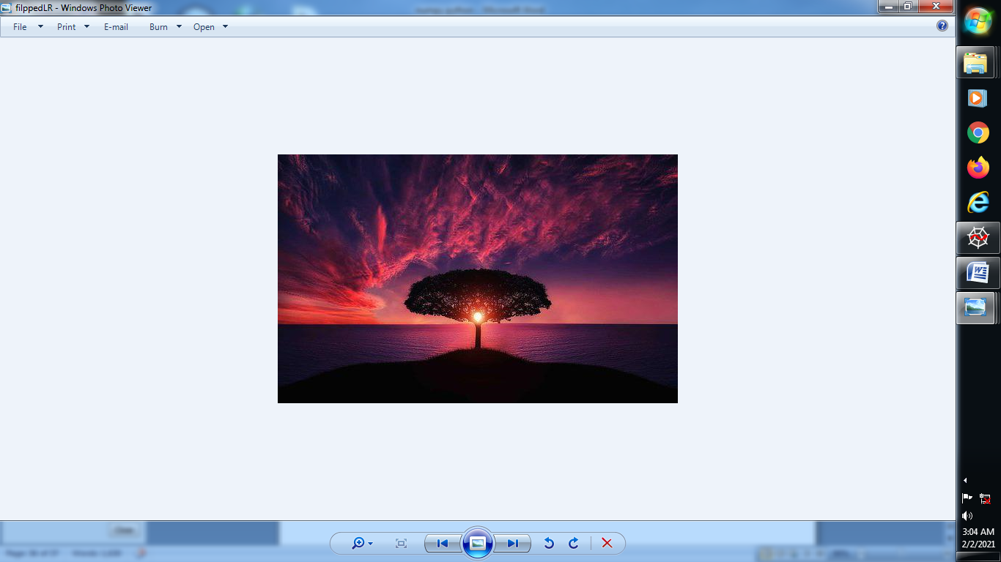

**TOP TO BOTTOM:**

**from PIL import Image**

**img = Image.open("C:/Users/abc/Desktop/image/test_image.jpg")**

**img_flipTB = img.transpose(Image.FLIP_TOP_BOTTOM)**

**img_flipTB.save("C:/Users/abc/Desktop/image/filppedTB.jpg")**

**→ Original Image:**



**→ Flipped Image(LR):**

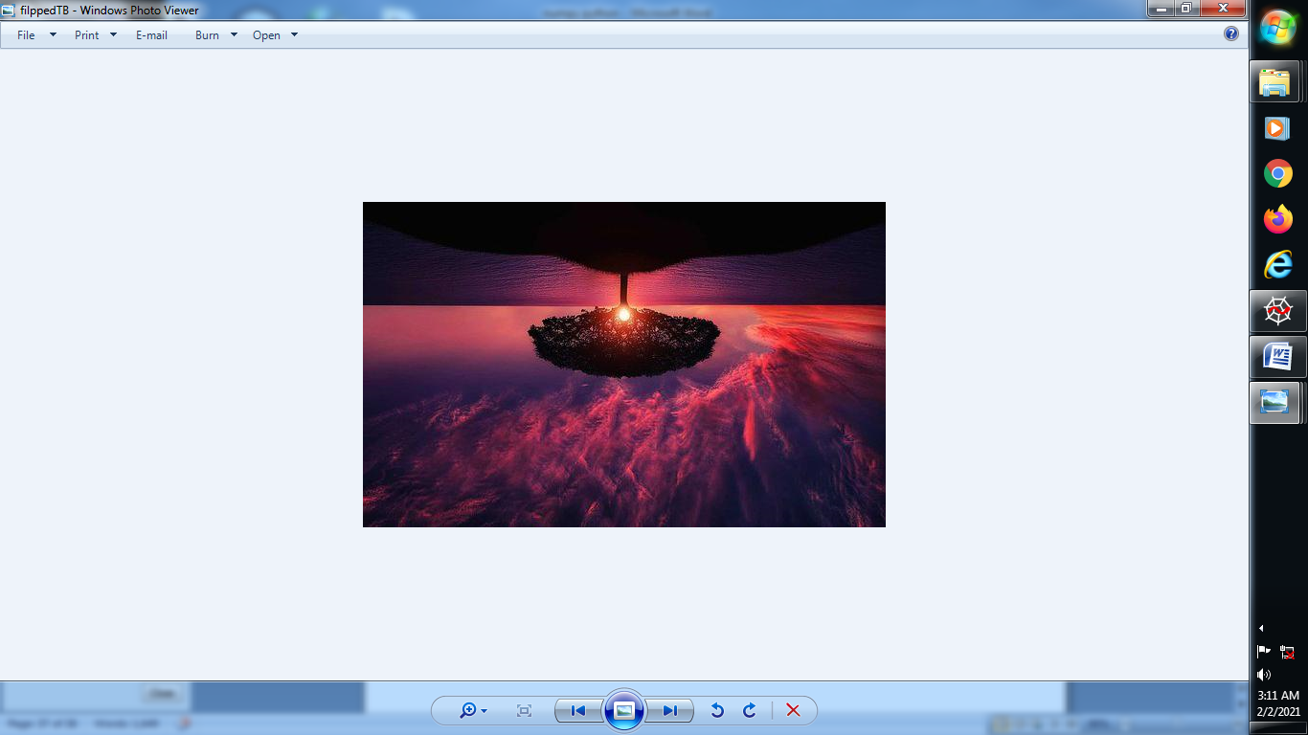

**(11) GrayScale Image :**

**PENDING WORK-------**

**(12) Glob Library:**

**from PIL import Image**

**import glob**

**path = "C:/Users/abc/Desktop/image/aeroplane/*"**

**for file in glob.glob(path):**

**print(file)**

**→ C:/Users/abc/Desktop/image/aeroplane\Lighthouse.jpg**

**C:/Users/abc/Desktop/image/aeroplane\maxresdefault.jpg**

**C:/Users/abc/Desktop/image/aeroplane\rgbimage.jpg**

**C:/Users/abc/Desktop/image/aeroplane\test_image.jpg**

**→ To Display that image by rotating at 45 degree:**

**from PIL import Image**

**import glob**

**path = "C:/Users/abc/Desktop/image/aeroplane/*"**

**for file in glob.glob(path):**

**print(file)**

**a = Image.open(file)**

**rotated45 = a.rotate(45, expand=True)**

**rotated45.save(file+"_rotated45.png","PNG")**

**→ It’s Rotate all the Image of that folder one by one :**

